Final Project: Pick a Project
Computer Science - Week 10
Oct 3, 2026 - Version 0.0.2
Please make sure to your UD email AND name is below. Unless your UD emails are included in this table, then you will not earn any points for this assignment when it is graded! Every person should submit their own individual worksheet.

Talk about each of the questions with a friend or our LLM (or both), but make sure the words you enter below are yours (with the obvious exceptions notwithstanding). Brainstorming is best done in full sentences, and the main goal here is brainstorming. It's worth reviewing the information in this series of pages in the Drafter documentation to gain a better understanding of the process.

Role | Name | Email
Developer (You) | Jimmy | Jimmyyin@udel.edu
Friend (optional)

Part 1: The Goal & Prior Implementations
- Identify the Goal: What specific goal are you trying to address? Think about your passions, hobbies, and academic interests. The latter are an excellent candidate to focus on. Some majors have suggestions listed below: these were provided by faculty in those departments. Other majors could consider a focus tied to a big final assignment in one of their recent courses in their major.
  - Biomedical Engineering majors may consider one of the following:
    - If you have started (or completed) the Cell/Tissue Design final project in BMEG100, design an organoid, which involves combining a cell type, biomaterial, and testing method. Have the website include a description and diagram of your design concept, a testing method, a needs statement, and an impact statement relevant to their organoid. Also include a link to a paper that supports your idea and a paragraph describing how that paper supports your design concept.
    - Otherwise, create a website related to your BMEG100 Lab Report 1, Cytoskeletal and Nuclear Staining Lab Report Guidelines, linked here (University of Delaware account required to access).
  - Chemistry and Chemical Engineering majors may consider creating an automated chemistry assistant that takes balanced reaction equations, starting reactant masses, and a harvested product amount to determine the limiting reactant, theoretical yield, and percent yield based on principles from Chemistry 2e (OpenStax) — Chapter 4: Chemical Reactions and Stoichiometry. To avoid manually compiling atomic mass tables or writing custom string tokenizers, use the ChemPy library to parse molecular formulas into exact molecular weights and verify reaction stoichiometry against compound data from the NIH PubChem Database. The program outputs an organized breakdown of limiting reagent status, product yields, and remaining masses of unreacted species. Also use the heat of the reaction to determine if it is exothermic or endothermic, and compute the heat flow per mole of the product.
  - Majors in the Electric & Computer Engineering department may consider a steganography project that hides messages in images, and then retrieves those messages from uploaded images.
  - Mechanical Engineering majors may consider a project that somehow uses both the NumPy and SciPy Python libraries.
A website to help you make small decisions

- Prior Implementations: Search the internet. What existing tools or websites currently attempt to address it?
Redecide, Argumentree, Wheeltoss

- Your Implementation: Briefly describe the legitimate purpose or functionality of your site. How would you want this web application to be used?
People use it for small and mostly inconsequential decisions if they can’t decide on something

Part 2: The Input-Process-Output (IPO) Model
Think about the fundamental flow of your program.
- The Core Goal: Every program has three main phases: taking input, processing data, and presenting output. In one sentence, what is the ultimate goal your program will accomplish for the user? Be specific and use CS1 concepts.
The goal this program will accomplish is to help the users make small everyday decisions if they can’t decide on something

- Input: What specific information will the user need to provide to your program? (e.g., a city name, a numerical budget, a list of hobbies).
They will need to provide different choices that they have the option to do, and choose a page to make the decision

- Processing: At a high level, how will the computer manipulate or evaluate that data? (e.g., calculate the average, filter out options that are too expensive, compare the input against a database).
There will be different ways to make the choice, one will assign different letters with different weights and then choose the heaviest or something like that, another will be purely random, and another could be more logical somehow.

- Output: What will the user get back? (e.g., a recommendation, a calculated safety factor, a formatted schedule).
The user will get back a recommendation for what to do among the choices they put in

Part 3: Data Abstraction
Identify the "nouns" of your problem.
- Representing Reality: Abstraction is the process of representing the real world inside a computer by ignoring unnecessary details. What are the core "things" (nouns) your program needs to track? (e.g., If building a recipe app, the nouns are "Recipe" and "Ingredient").
Choices and options

- Identifying Properties: For the most important "thing" you listed above, what 3 to 4 specific details do you actually need to solve your problem, and what details will you abstract away?
  - Details I need: (e.g., Ingredient name, weight, cost)
  - Details I will ignore: (e.g., Ingredient color, brand, expiration date)
I need option names, descriptions, and importance weight

Part 4: Challenges, AI Strategy, & Goals
- Difficulties: What parts of this project seem the most difficult or technically complex?
The part on how to decide what option the website will pick and how it goes about it.

- Coding Strategy: If you will be using an LLM to help code, how will you ensure you understand the generated code and avoid "hallucinations" or "shallow learning" (copying without understanding)? If you won't be using an LLM to help code, this project might take about 4 hours a week to complete, so list each of the days and times in which you work on the project.
I will ask the LLM to explain each part and test sections to see that they work

- Goals: What is your ultimate goal for this project? (e.g., Impress the graders with a creative UI, build something I can use in my other classes, learn Drafter deeply).
My ultimate goal is a get a good grade, if it actually has ot be something then help people make decisions or something

Part 5: Research & Brainstorming Conversation
Have a conversation with a Generative AI tool (like ChatGPT or Claude) OR a friend about your project idea. Do not ask for code. Instead, use the AI/friend as a sounding board to research your problem.
- The Initial Prompt/Question: Ask the AI or your friend to help you brainstorm. (e.g., "I want to build a simple web tool to help students track their study hours. What are 3 common problems students face when tracking their time, and what are 3 simple features a basic tool should have?"). Paste your prompt below:
I want to build a simple web tool to help people make simple and incosequential decisions , what are some things I might need to implement to make it interesting

- The Response: Briefly summarize the best ideas the AI or your friend suggested. What existing solutions or prior apps did they mention?
It gave a bunch of options and core features that I could implement

- The Pushback: You must reply to the AI/friend to narrow the scope when it's over-ambitious. Pick the most complex feature they suggested and explain why it is too complicated for an introductory programming project. Ask them for a simpler alternative. Paste your response here:
narrow the scope and select a few important features

- Reflection: Based on this conversation, how has your project idea changed or become more focused?
I could try to add a fun animation to get more routes and for it to be interesting

Part 6: Resource Planning
- What resources will you use if you get stuck?
I will ask my peers and look up resources online, and ask LLMS

- If your LLM provides code that causes a Drafter or Bakery error, or if you run into a problem during deployment, what is your step-by-step debugging plan to resolve it?
I plan to ask the ai to try again, paste the error message, and try the new code, if it fails i will attempt this a few more times before trying to manually figure out the problem and either fix it myself, or tell the ai to do something more specific to fix the problem.

Part 7: LLM Conversation
If you used an LLM in any part of this work, copy and paste every part of that conversation below. Otherwise, you may be given a zero for the assignment. Obviously, these words will not all be yours, and this is the exception to the requirement at the top of this assignment that all responses be in your own words. If you did not use an LLM to assist you in this assignment, simply say so below.
I used an ai for part 5, its a lot of pictures to take so i will just paste the conversation: I want to build a simple web tool to help people make simple and incosequential decisions , what are some things I might need to implement to make it interesting
I think this is a genuinely fun idea because people spend a surprising amount of mental energy deciding things that don't really matter — what to eat, what to watch, what to do first, or whether to go out or stay in.
I'd build it as a mix of a decision-making tool and a little entertainment product. The goal isn't just to give people an answer; it's to make choosing feel effortless and fun.

1. Core features I'd implement
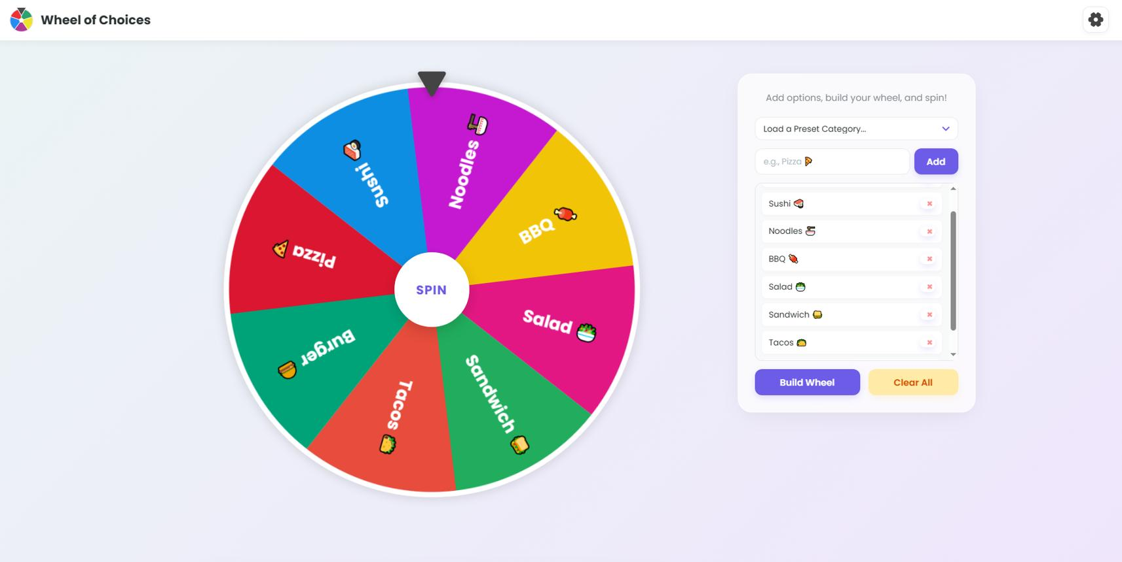

1. The Decision Wheel
Start here
Users enter a few options, spin a wheel, and get a random result.
- Add, edit, and remove options.
- Animate the spin and reveal the winner.
- Let users reroll if they really don't like the answer.
- Offer preset wheels for food, movies, activities, and more.
Why it works: It's visual, immediate, and satisfying to use.
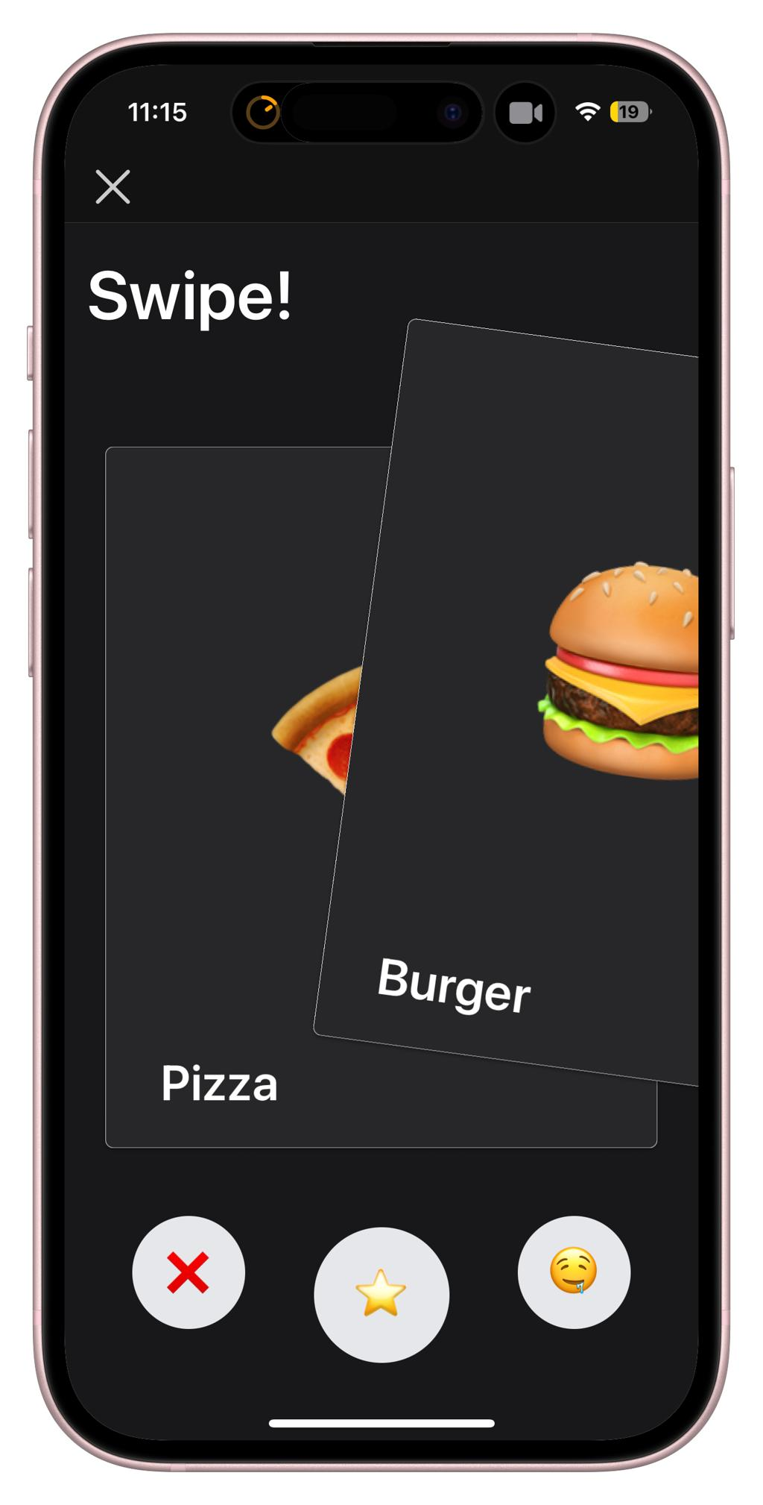

2. This or That
Present two choices at a time until one winner remains.
- Pizza vs. burgers
- Movie vs. video game
- Stay home vs. go outside
Users tap one option, and the app generates the next matchup.
Why it works: It turns a boring decision into a tiny game and is especially good on mobile.
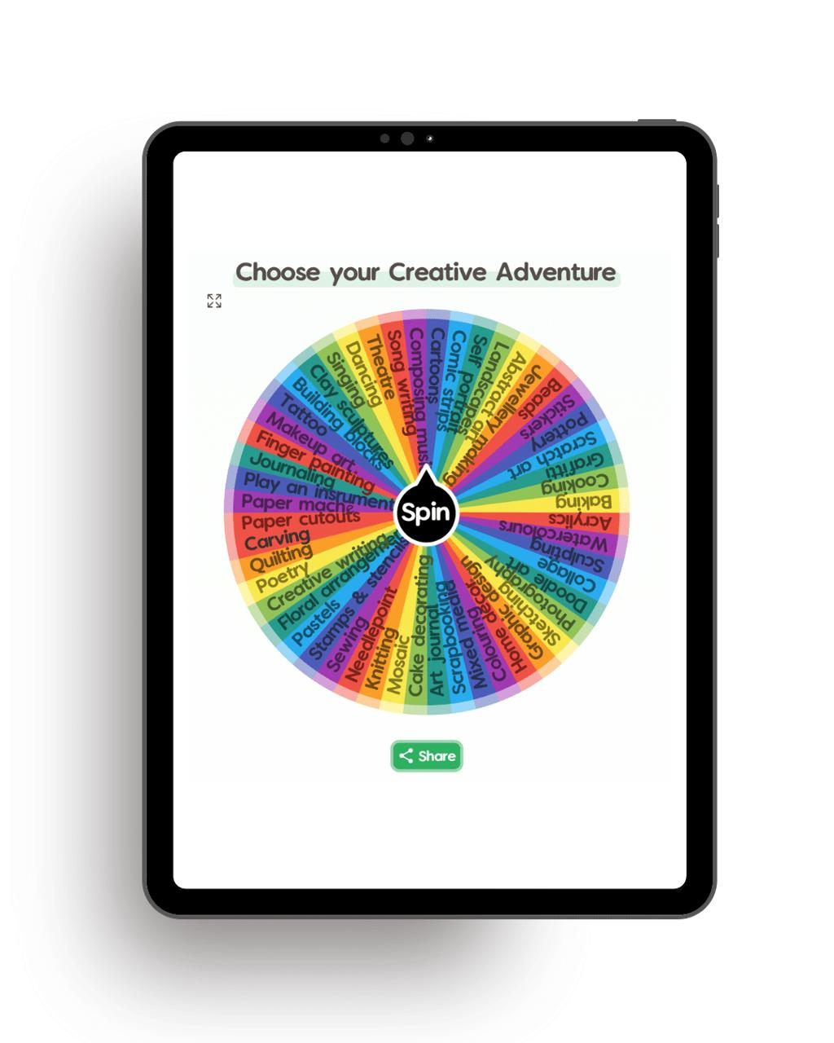

3. The "Just Decide for Me" Button
A single button for people who don't want to think.
The user chooses a category, presses the button, and gets a suggestion instantly.
Examples:
- What should I eat?
- What should I do for the next 30 minutes?
- What should I watch tonight?
Why it works: Almost zero friction. Someone can open the site and get value in seconds.
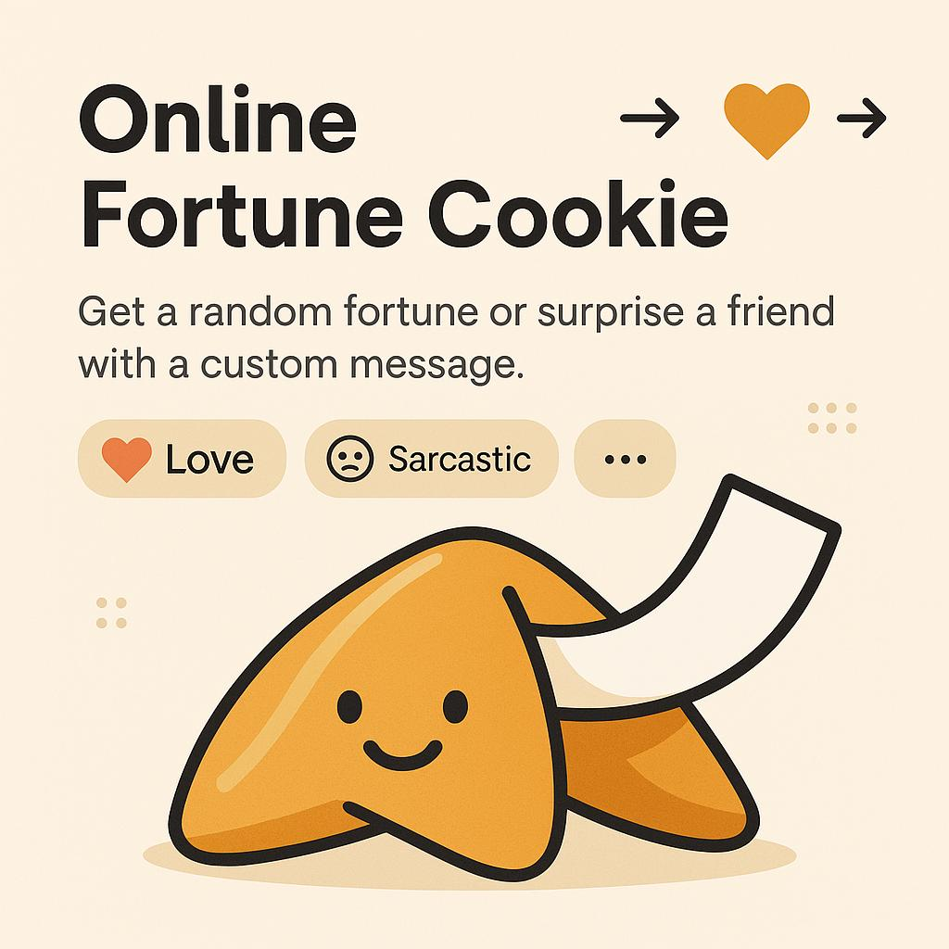

4. Silly Decision Modes
Give people a reason to smile at the result.
- Coin of Destiny: heads or tails, with a fun reveal.
- The Oracle: dramatic answers to trivial questions.
- Chaos Mode: a completely unexpected suggestion.
- Fate Has Spoken: the answer appears with an absurdly serious explanation.
Why it works: Personality makes the product memorable and shareable.
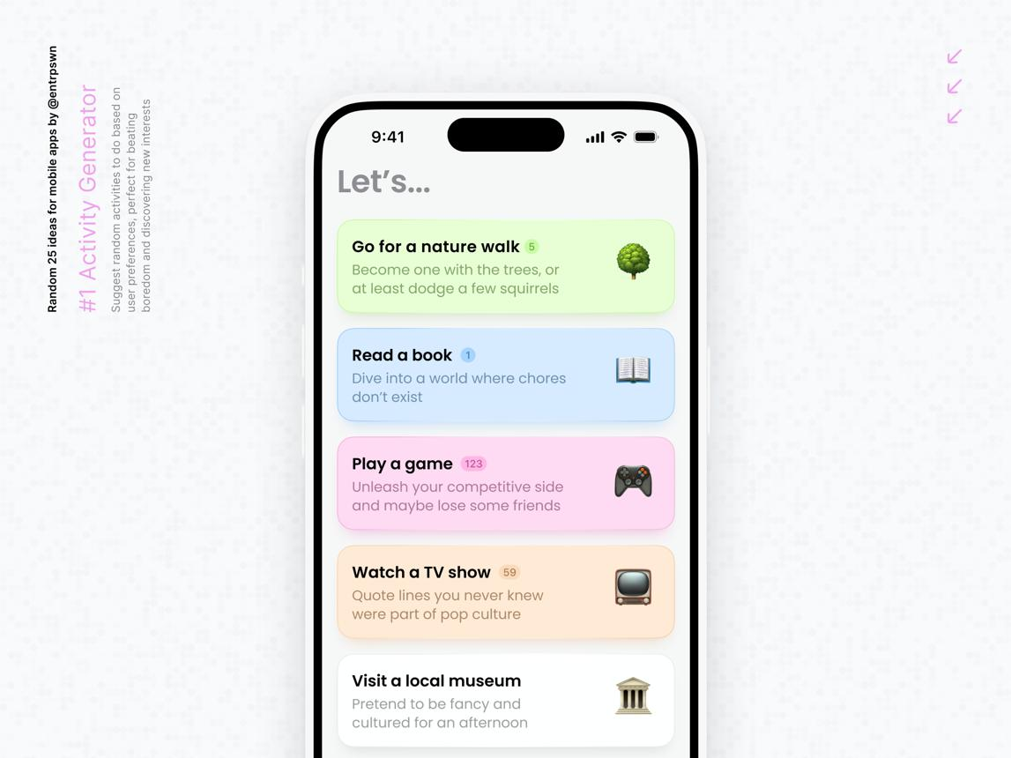

5. Random Mini-Challenges
Go beyond choosing between options by suggesting something small to do.
Examples:
- Listen to a song you haven't heard in years.
- Take a five-minute break.
- Try a snack you've never had.
- Send a friend a funny meme.
Why it works: The tool becomes a source of inspiration, not just a random number generator.

2. Small details that make it addictive—in a good way
These are the features that could distinguish your site from a basic randomizer.
Personality in the results
Instead of just displaying "Tacos," show "The universe has spoken. Tacos are your destiny." Make the tone customizable: serious, chaotic, wholesome, or sarcastic.
Decision history
Let users see their last few results, undo a decision, or revisit a previous suggestion. Store it locally in their browser if possible.
Group decision mode
Everyone submits an option, and the tool picks one. Great for deciding what a group of friends should eat or play.
Weighted choices
Users can make some options more likely than others. For example, if they're happy with either pizza or sushi but slightly prefer pizza, the wheel can reflect that.
Shareable decisions
Generate a link or a shareable result card. Friends can open a preset decision or see the funny outcome.
Sound and animation
Add a wheel tick, a coin flip, confetti, or a satisfying reveal. Include a mute option and respect reduced-motion settings.

3. Give the tool a distinctive identity
I'd avoid making it look like a generic productivity dashboard. A more playful identity could help it stand out.
Here are three possible directions:
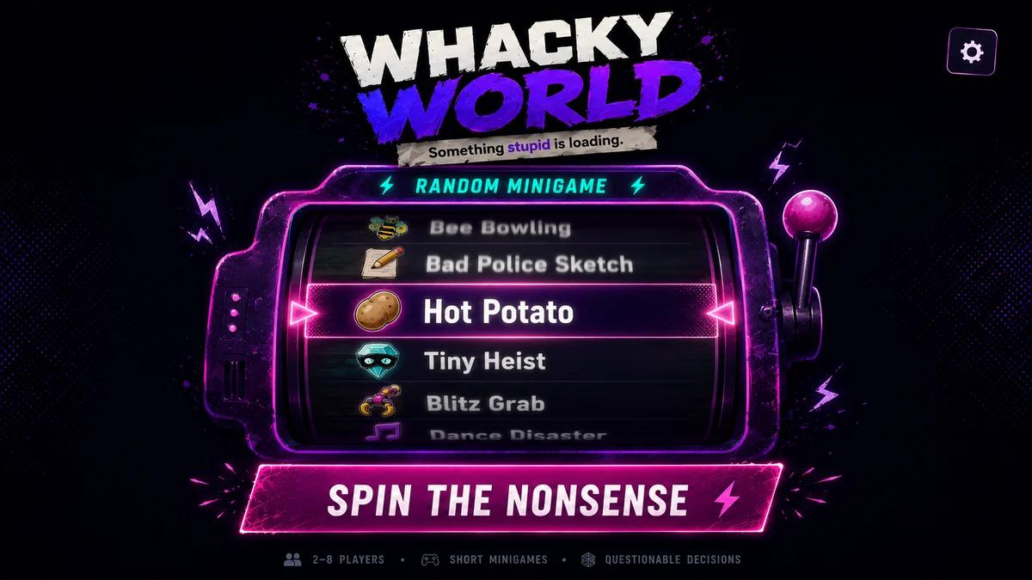
The Decision Arcade
Playful · Energetic · Gamified
Every decision is a mini-game, with sound effects, streaks, and silly achievements.
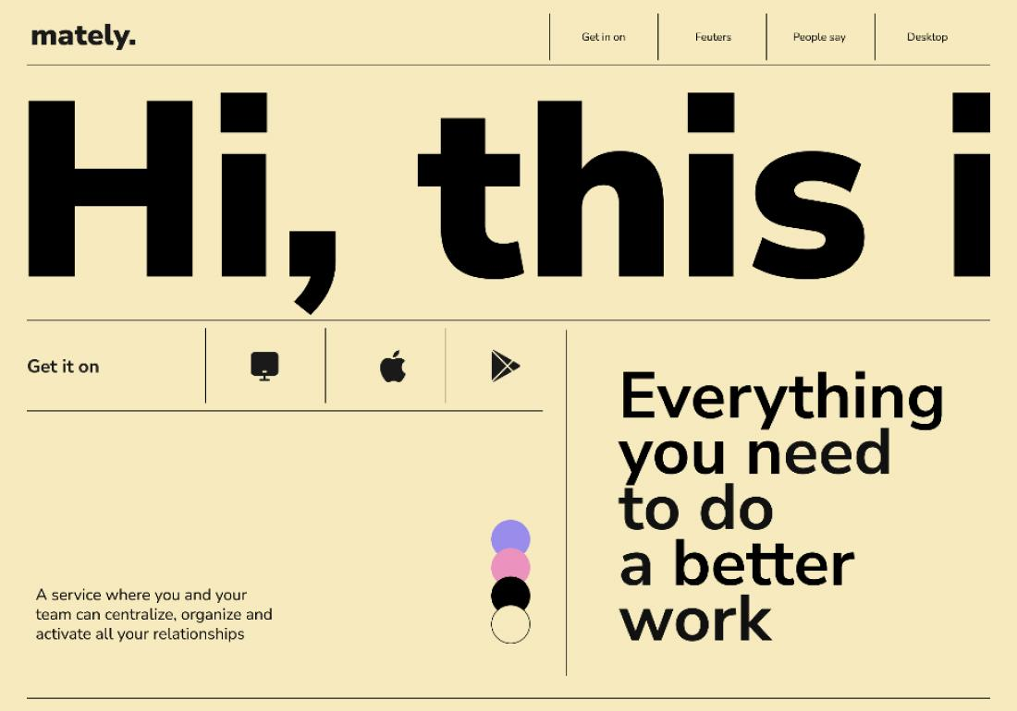
The Decider
Clean · Fast · Practical
One input, one button, one answer. Minimal distractions and a focus on speed.
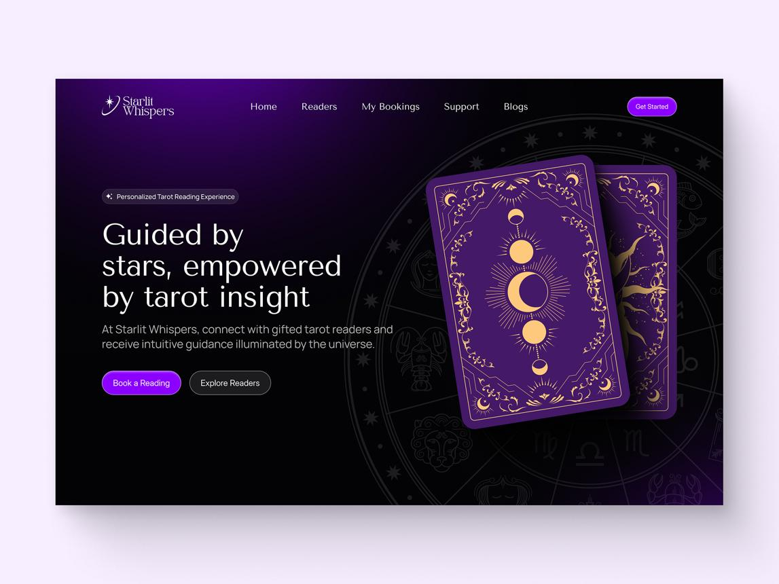
The Oracle
Mysterious · Funny · Dramatic
Every trivial choice gets treated like an ancient prophecy. Perfect for humorous results and shareable screenshots.
My preference would be The Decider with The Oracle's personality: an extremely simple interface that occasionally behaves in a ridiculous way.

4. What the actual website could look like
Here's a potential homepage layout.

decide.
Your brain can rest.

Too many options?

We'll pick one.
For the little decisions that shouldn't take all day.
What are we deciding?
Food
Movies
Activities
Custom
We'll choose from a set of food suggestions.
No big decisions. No overthinking. Just go.
Interactive concept: the buttons above demonstrate how a simple decision interface could work.

5. What I'd build first (MVP)
Don't build everything at once. The biggest risk is spending weeks implementing features before finding out which ones people actually enjoy.
Priority | Feature | Why
1 | Random choice generator | The core value
2 | Custom options input | Makes it useful for any decision
3 | Animated wheel or reveal | Makes it fun
4 | Preset categories | Makes starting effortless
5 | Reroll and undo | Reduces frustration
6 | Shareable results | Encourages discovery
7 | Saved wheels | Makes repeat use easier
For a first version, you can build almost everything with ordinary frontend code. You probably don't need a backend, accounts, or a database yet. Use browser storage for saved choices and history, and add a backend only when shared data or accounts become necessary.
One important product detail: make randomness transparent. If a choice is random, say so. Let users set weights, remove options, or reroll, and don't imply that the tool knows what's genuinely best for them.

6. A few ideas that could make it spread
- "I let a website decide my entire afternoon." A fun challenge users can share.
- Decision of the day. One weird prompt for everyone to try.
- Public preset library. Users create and share wheels for different situations.
- The regret button. After a result, users can say whether they accepted it. Track the percentage of decisions people actually follow.
- The indecision meter. A playful animation that gets more dramatic the longer someone delays choosing.
- Decision roulette. Combine multiple categories for a completely random activity suggestion.
I'd prioritize the regret button and decision roulette after the MVP. They give the product a little identity beyond the usual spinning wheel.

7. Three questions that will help shape the best version
1. Who do you imagine using it most?
Anyone with everyday decisions
Friends deciding things together
Students looking for fun or inspiration
People who want to stop overthinking
2. What vibe are you going for?
Fun and playful
Minimal and fast
Funny and chaotic
Polished and useful
3. What's your initial ambition?
A quick weekend prototype
A polished standalone web app
Something designed to grow and get shared
My main advice: make the decision itself take one second, and make the experience of getting the answer the fun part. That's what could turn a tiny utility into something people remember.
narrow the scope adn select a few important features
I'd narrow it down to a simple web app with one purpose: help people make small decisions in seconds, without overthinking.
For the first version, I'd build just 3 core features and leave everything else for later.

The MVP: 3 essential features

1. Custom choices
Users enter the options they're deciding between.
- Add and remove options.
- Start with at least two choices.
- Example: Pizza, burgers, or sushi.
This makes the tool useful for almost any everyday decision.

2. Random decision generator
One prominent button picks an option at random.
- Show a brief animation.
- Reveal the selected option clearly.
- Include a reroll button.
This is the core functionality and the main reason to visit the site.

3. Fun result presentation
Make the result feel satisfying rather than displaying plain text.
- A playful message such as "The universe has decided!"
- A small reveal animation or confetti.
- A simple, memorable visual style.
This gives the tool personality without adding much complexity.

What the first version should look like

decide.
Stop thinking. Start choosing.
Pizza
Sushi
Burgers
Interactive prototype · Try adding options and making a decision.

What to leave out for now
Feature | Decision | Reason
User accounts | Later | Unnecessary for the core experience
Saved history | Later | Not essential for occasional decisions
Group decision mode | Later | Adds complexity
Weighted choices | Later | Most users just want a quick random pick
Social sharing | Later | Validate the core tool first
Multiple game modes | Later | One excellent mode is enough initially

Suggested build plan
- Build the interface: option list, input field, and decision button.
- Implement the logic: random selection, validation, and reroll.
- Add personality: a short animation and fun result reveal.
- Test it: make sure the experience works well on mobile and desktop.
You shouldn't need a backend for this version. Plain HTML, CSS, and JavaScript—or React if you prefer—will be enough.
The success criterion: a new visitor can open the site, enter a few choices, and get a result in under 10 seconds.
Once that's working well, you can decide whether the next feature should be preset categories, saved choices, or sharing.

Part 8: Submit
In Google docs, with this document open, please click on File > Download > Microsoft Word (.docx), and make sure you put that download somewhere you can find it again. Then, upload it to the Canvas assignment about selecting or brainstorming your final project.

When you're done with this assignment, review this page of the Drafter documentation to better prepare for the next step.

